How we hold working meetings.

November 29, 2018 a meeting of representatives of all clubs of St. Petersburg.
We listened to the story by Alexey Vasilyev, PRD, about a trip to the South Korea convention in August 2018.
Alexey brought us souvenirs from the Y 's Men of Korea. Everyone was very pleased.
We accepted Anna Shelegova, who had moved in from Ekaterinburg, into our ranks.
We discussed upcoming trips to orphanages and correctional schools in the village of Efimovskiy and pos. Volosovo on Christmas and New Year holidays.
We decided which volunteers we would attract for this work.
We awarded the Russian balalaika (she is in the photo) and congratulated Alexey's assistant - Polina Belova.
The Russian balalaika is the emblem of the Y 's Men of Russia.

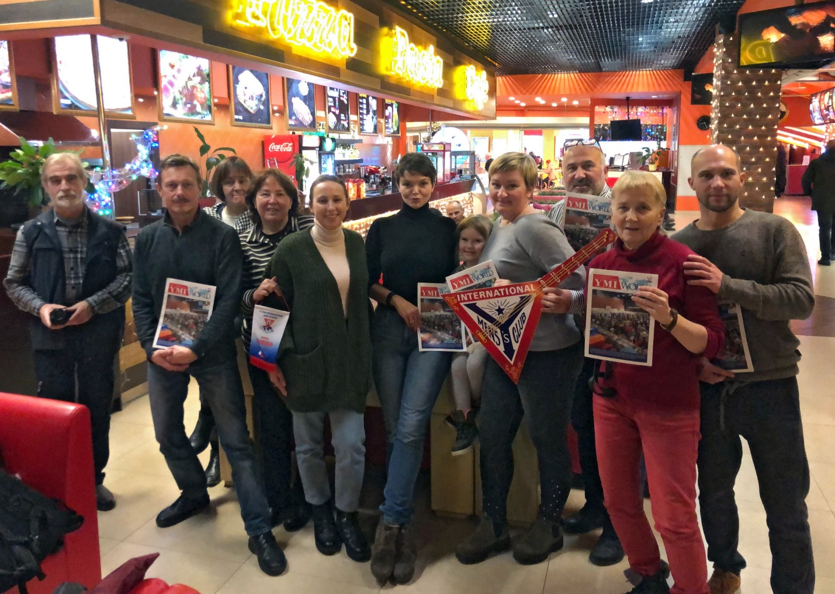
Natalia in the photo - in a striped jumper

