Pärnu, June 2018
In June 2018, members of the Y’s Men club Ingria Natalia Smirnova and Olga Adamovich took part in a seminar CHRISTIAN EMPHASIS, which was held in Pärnu, Estonia.
Despite the fact that I have been in the Y’s Men movement for more than 10 years, I took part in this seminar for the first time.
Why did I want to take part in this seminar right now?
Now we live in an unstable world where there is a lot of violence and injustice. In my family there was a loss of a loved one. And I was very acutely faced with the question of how I can help others if I need help myself?
The seminar helped me to understand that the forces are within us and if we are together, then we are stronger several times.
Led the seminar Carl Hertz Jensen ASD CE PAP, DG
During the CE seminar in Parnu, we became acquainted with the charitable activities conducted by the Estonian Y’s Men.
I present you pictures from the CE seminar in Parnu.
Another experience and contacts with our neighbors are very useful for us.

This seminar, as it turned out, was very important for the further development of our movement.

More information can be found on the website Y's Men International. Area Europe https://www.facebook.com/groups/134529900503343/

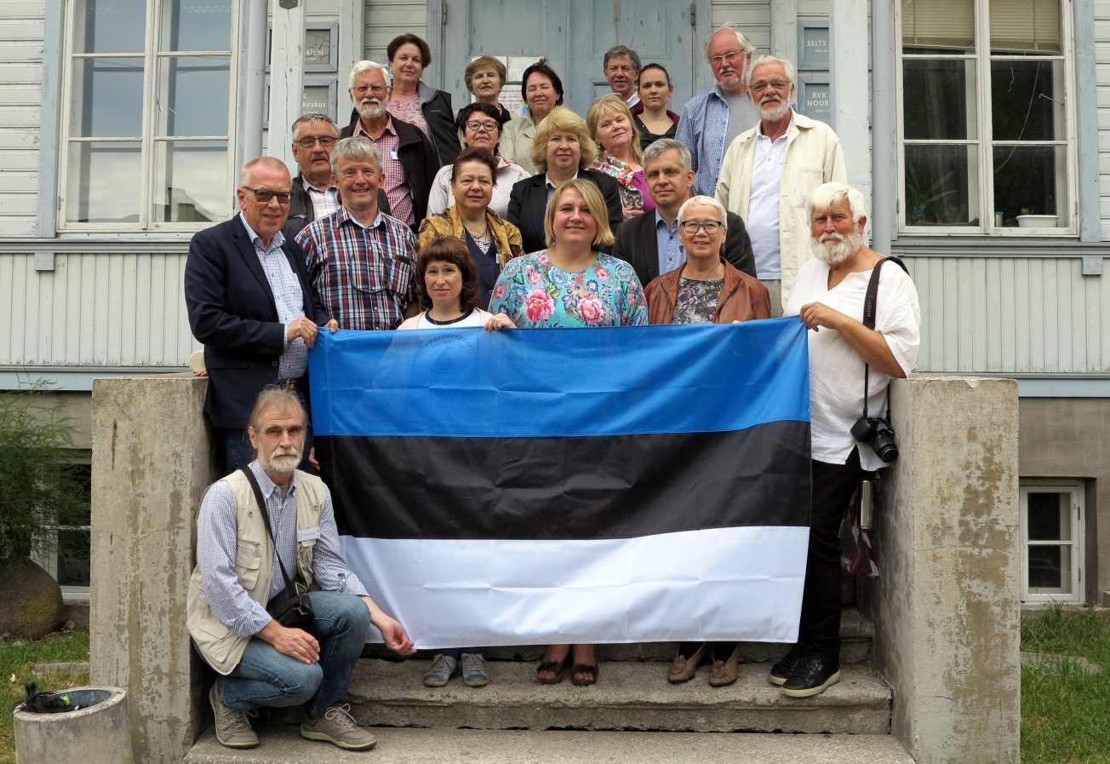
The main photo of the seminar participants
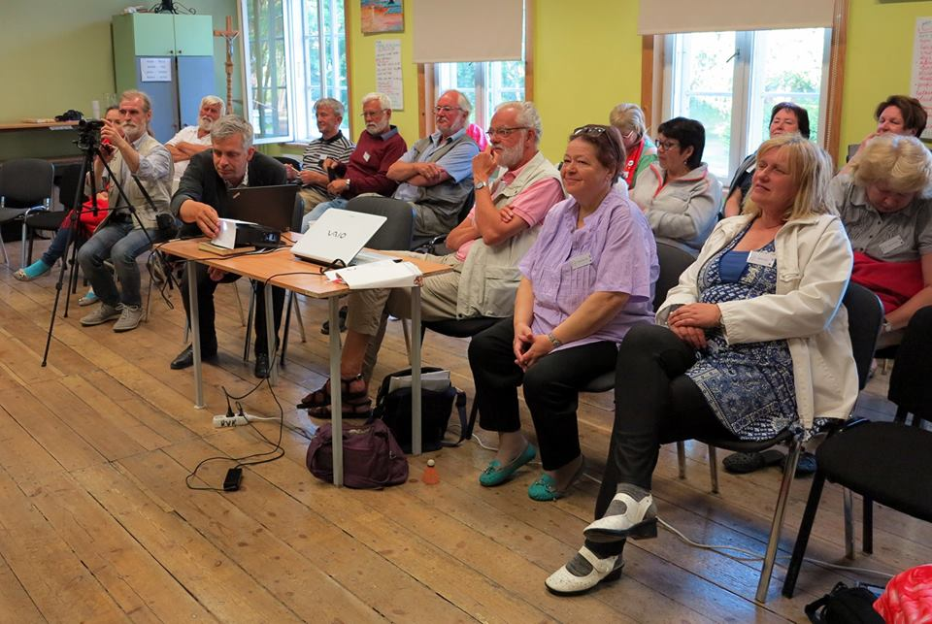
Seminar Presentation

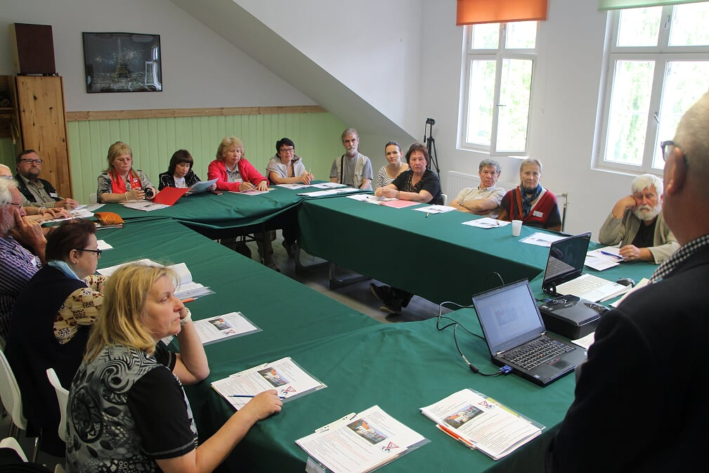
Collaboration at the workshop

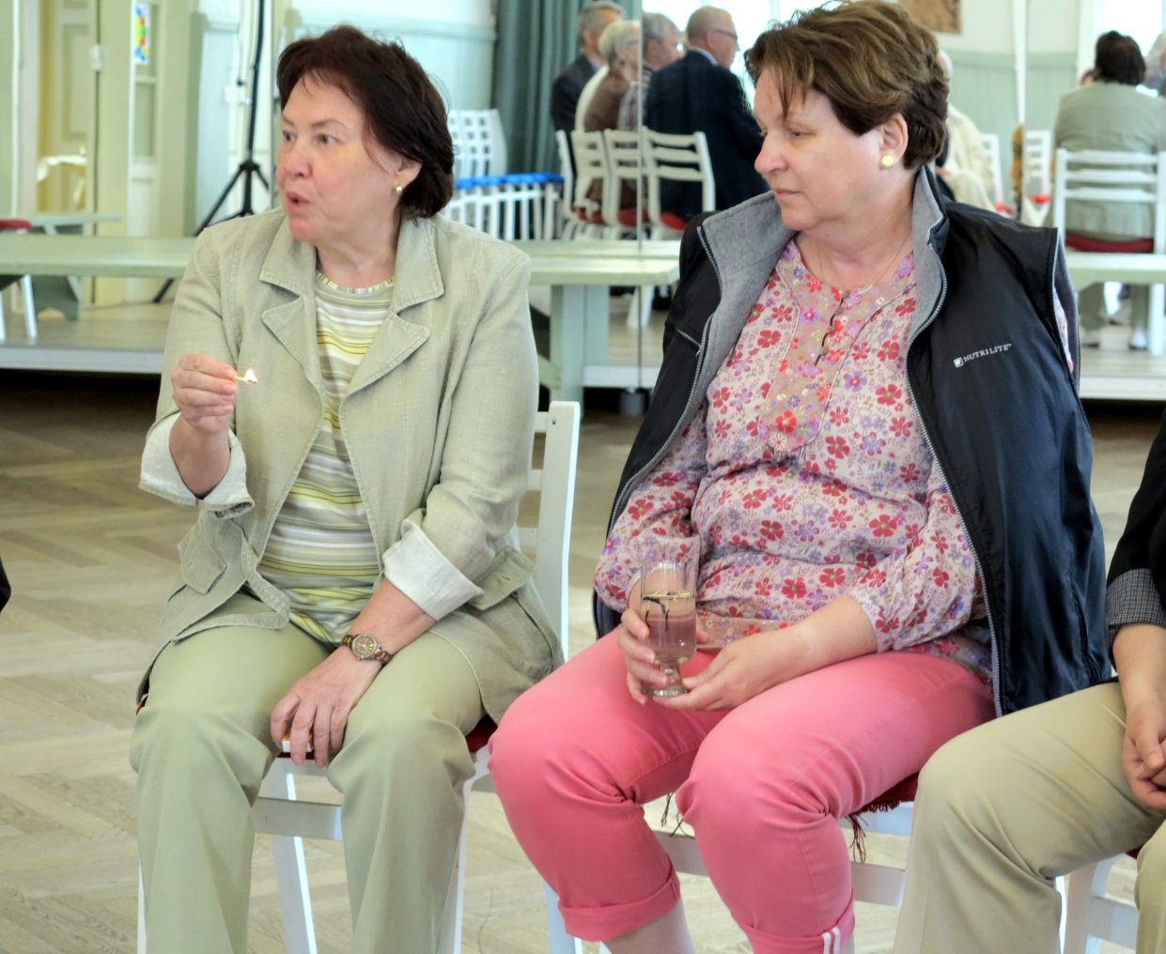
Natalia and Olga on the general discussion

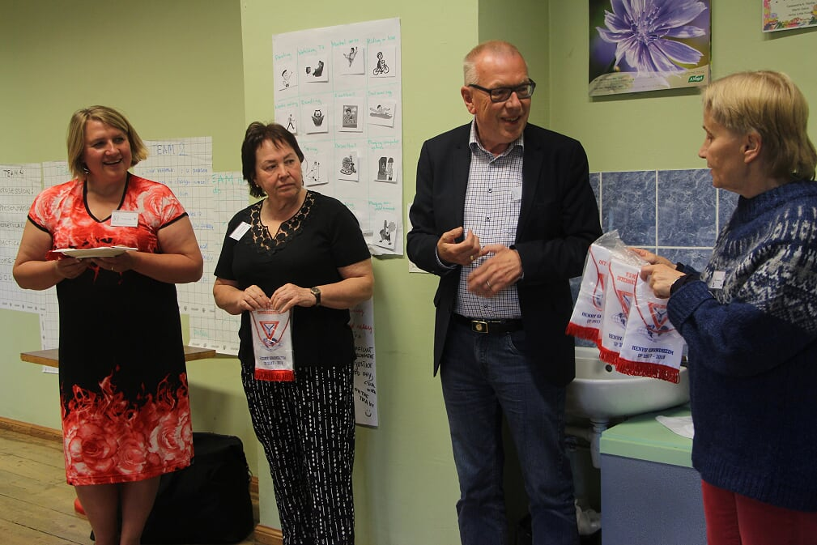

Henry Grindheim IP 2017-2018 hands a personal banner as a sign of good teamwork throughout the year

